

Communication Friendly Classroom Audit – Key Stage 2
School |  |  | Year Group |  | Date |  | Observer

Teaching strategies
 |  | RAG | Comments | Even Better if/ Resources
1 | Adults speak clearly and slowly  They adapt their communication to meet the needs of identified students
2. | Instructions are clear and simple  Adults check that students have a clear understanding of what is expected of them
3. | Use of modelling  Talk through modelling to show thinking process
4. | Questions are used thoughtfully  Practitioners incorporate a variety of question types for different purposes and differentiate questions to meet students' ability. Identified students are always given enough processing time to respond to questions.
5. | Key information is broken down and presented alongside visuals
6. | Sentence starters are given to promote discussion  Use of sentence starters to provide a framework for sharing their ideas e.g. I think …… because…..
7. | Modelling language with appropriate grammar and vocabulary to their level of language

Language Rich Learning Opportunities
 |  | RAG | Comments | Even Better if/ Resources
1. | Direct language learning opportunities such as extending of a student’s language
2. | Opportunities for structured talking activities during whole class discussions.  Talking Partners especially before written work to promote verbal planning
3. | Understanding of narratives/genres is supported by exemplar texts, writing frames and modelling
4. | Opportunities for collaborative work  Working in pairs or small groups.
5. | Opportunities to make learning activities meaningful to students  By linking learning activities to students’ interests or own experiences.

Use of Visual Resources
 |  | RAG | Comments | Even Better if/ Resources
1. | Visuals are used to support understanding  Objects, pictures and symbols are used alongside spoken language and written text
2. | Labels for classroom resources  To create independency where students can gather the resources they need.
3 | Vocabulary displayed, easily accessible and referred to during class discussions and writing times.  There is a greater awareness of teaching curriculum specific vocabulary.
4. | A visual colour coded system in place to support spoken language and literacy activities i.e. colourful semantics/ shape coding (optional)

Socio- Emotional Strategies
 |  | RAG | Comments | Even Better if/ Resources
1. | Students are prepared for transitions  For example, use of sand timers to prepare for activities changing
2. | Active listening skills are explicitly taught and praised.  Reasonable adjustments are in place to acknowledge listening looks different for each student
3. | Positive, encouraging comments far outweigh negative, prohibiting comments
4. | Checking understanding – Students reflect on their own learning  Checking understanding by asking students to reflect and explain their own learning through self-assessment & self-advocacy approaches

Workshops to support Audit:
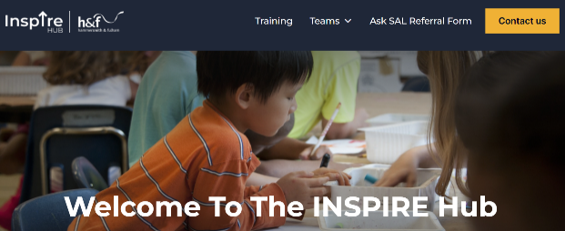
All workshops can be booked through the INSPIRE website at https://lbhfinspirehub.com/
-Promoting oracy in the Primary curriculum
-Scaffolding the curriculum for Students with SLCN

