INSERT PICTURE OF FRONT OF SCHOOL

Look! The logo is a ……! I wonder where you will see this when you visit?

INSERT PICTURE OF FRONT OF SCHOOL

INSERT PICTURE OF THE ENTRANCE

INSERT PICTURE OF THE CLASSROOM

INSERT PICTURE OF OUTSIDE AREA

INSERT PICTURE OF THE LUNCH HALL.

What activities can you see here?

INSERT PICTURES OF INSIDE / OUTSIDE ACTIVITIES, RESOURCES AND EQUIPMENT.

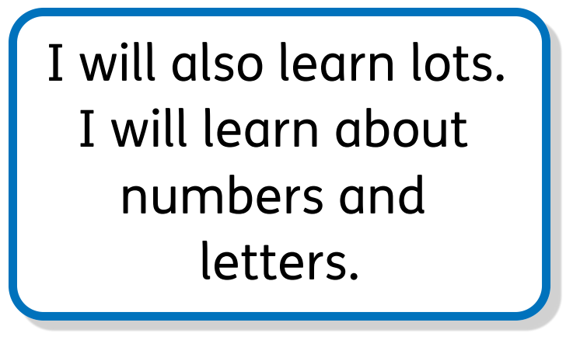

INSERT PICTURES OF ADULTS WHO WILL WORK WITH NEW PUPILS.

